

Cloude Project

[Document subtitle]



[Date]

[Company name]

[Company address]

Usman Saleem

21F-9277

Installation...

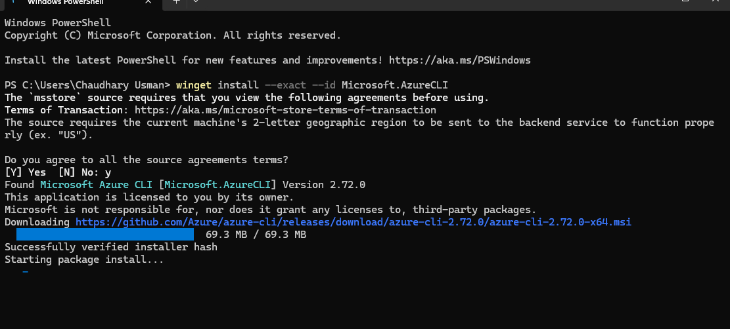

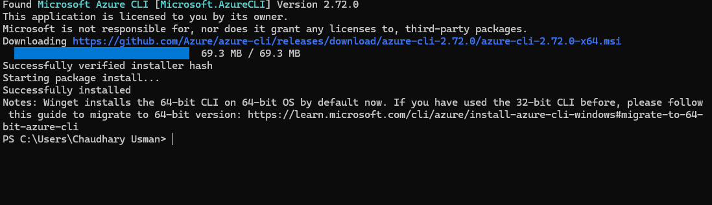

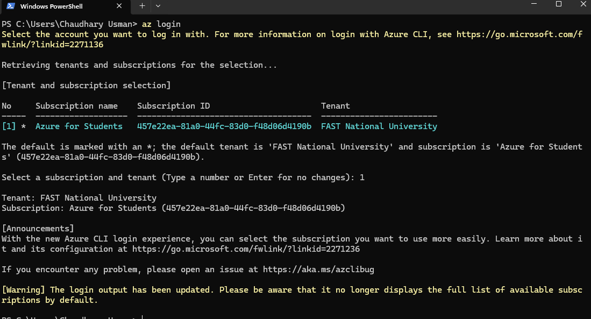

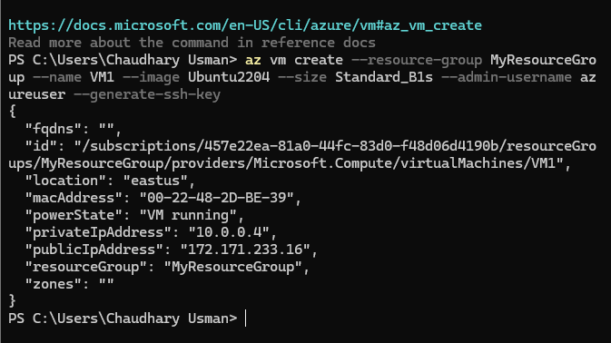

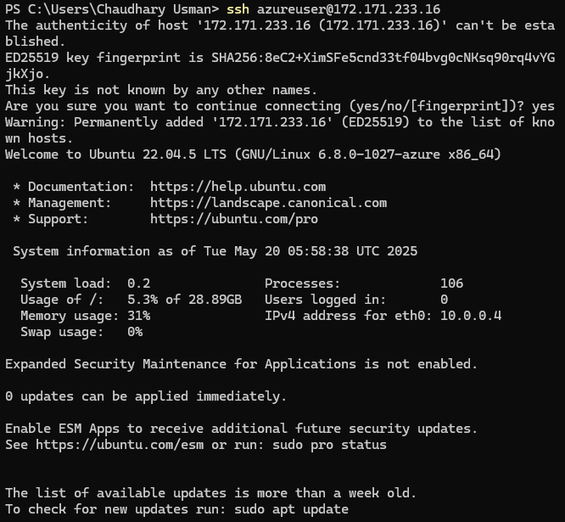

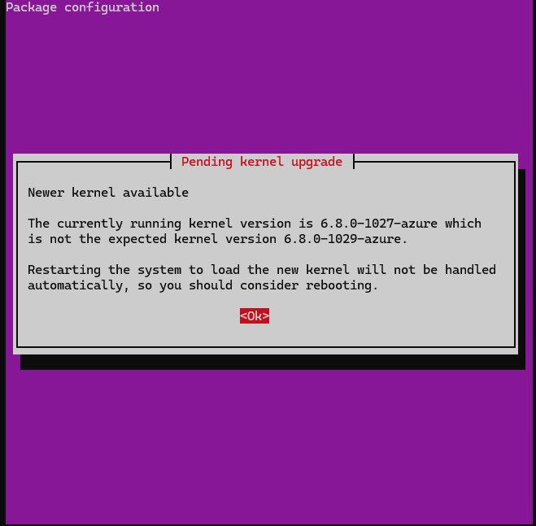

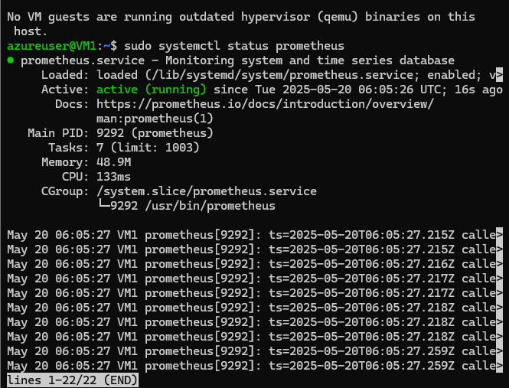

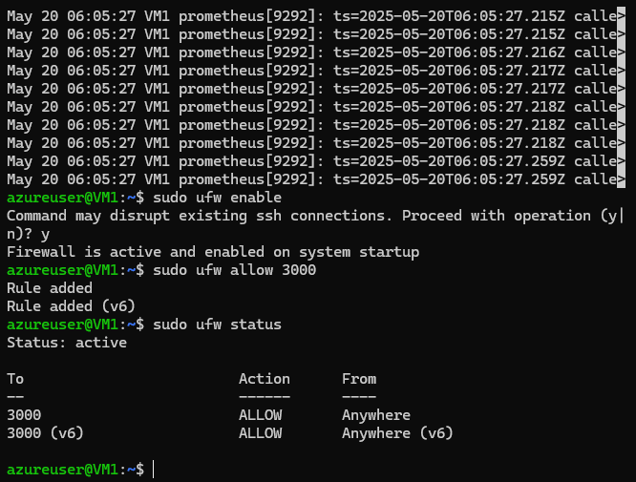

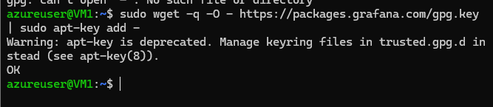

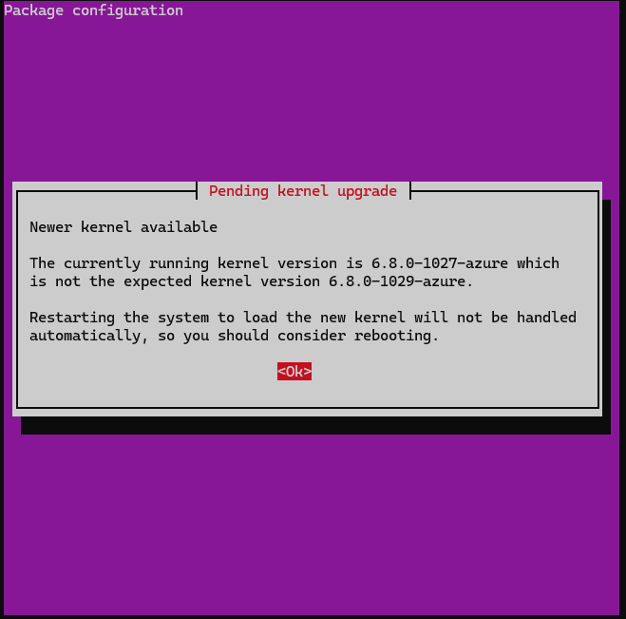

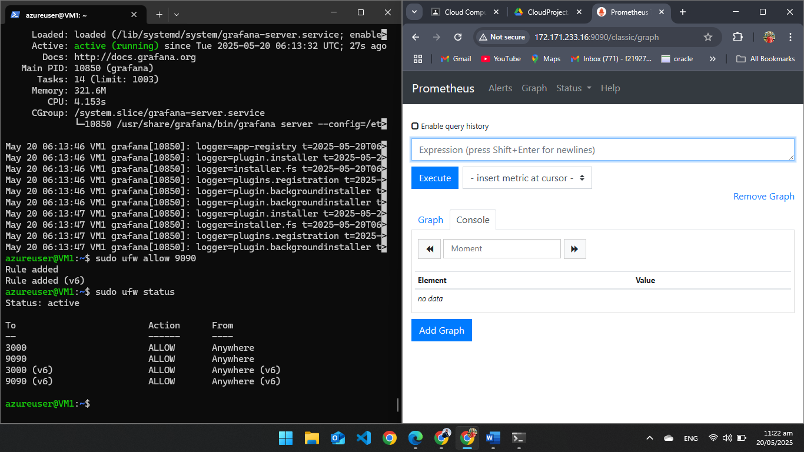

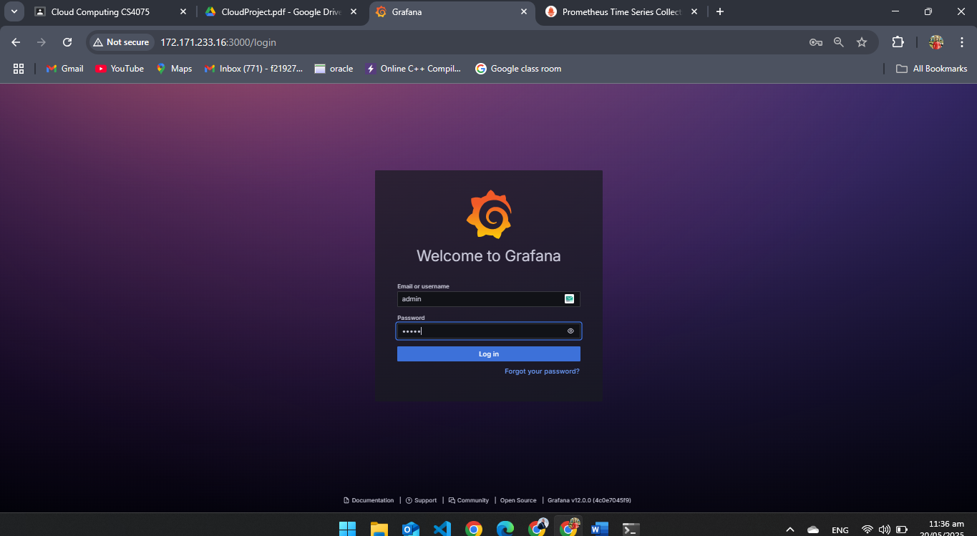

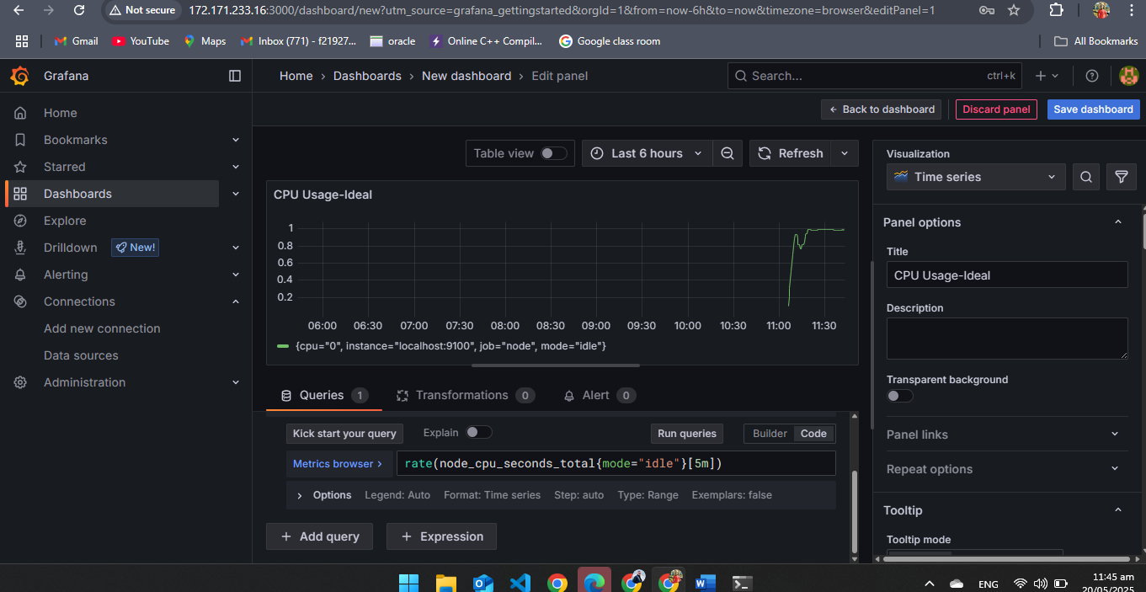

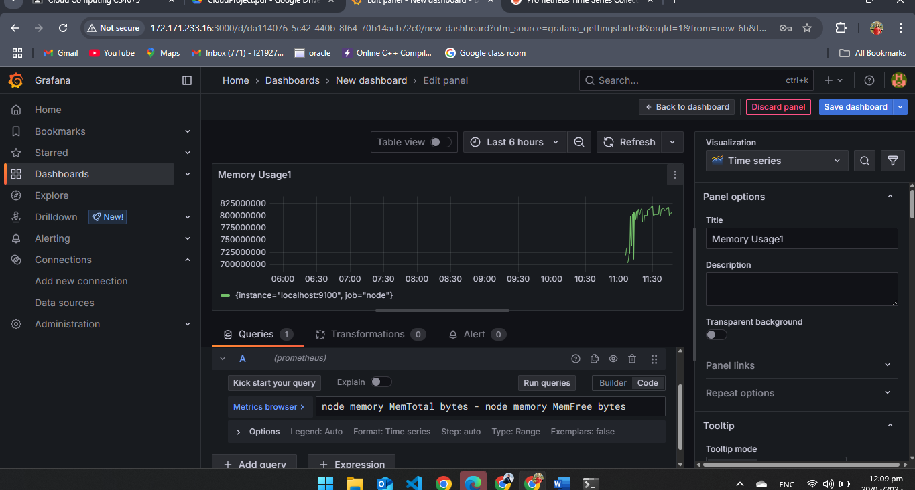

**2nd VM Setup**

